# Botluck: A Communal Recipe Finder

## Name Ideas

ShareMyFood

Foodsplit

BananaSplit

Potluck

***Botluck***

Food Right Meow

## Competitive Analysis

Ingredient-Based Recipe Finders:

* allrecipes.com
* Recipe Puppy
* supercook
* bigoven

Shared Grocery Lists:

* [AnyList](https://itunes.apple.com/us/app/anylist-grocery-shopping-list/id522167641?mt=8): IPhone app. Collaborative shopping list with links to recipes
* Havent found applications dedicated to sharing ingredients

There are no known services that combine collaborative grocery/ingredients lists and ingredient based recipe finding.

## Design Process

**Initial storyboards:**

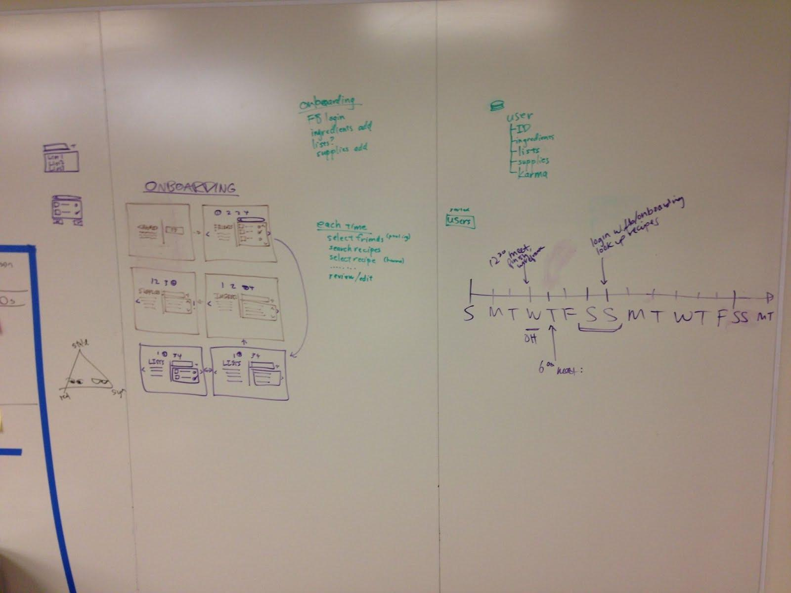

## Information Architecture

**User**

* Number id
* String userName
* String password
* String name
* Ingredient[] ingredients
* Number[] friends
* Utensil[] utensils
* Number karma
* Number[] history
* Number[] currentMeals
* Invites[] invites
* void addFriend(userID)
* User fromJSON(data)
* void updateServer(callbackfn)
* void initFromServer(id, callbackfn)
* void acceptInvite(mealId) // updates server about acceptance

**Recipe**

* String title
* Ingrdient[] ingredients
* String url
* String thumbnail // url of thumbnail

**Ingredient**

* String name
* Number amount
* Number price

**Utensil**

* String name
* Number amount

**Meal**

* Number id
* String ownerID
* String name
* Recipe recipe
* Bool recipeChosen
* FriendList userIDs
* <Number, Ingredient[]> contributions
* Date startTime (when created)
* Date endTime (when da meal get eateted)
* void initFromServer(id)
* void updateServer(callbackfn)
* void inviteUser(userId) // invites user to join meal

**Invite**

* String userID
* String mealID

**MealFinder**

* void findMeals(ids, p, callbackfn) // this function takes a list of ids and queries recipe puppy to get the 10 result of the page p, and passes the results to the callbackfn

**Directory Structure**

* app.js
* static/
  + html/
  + js/
  + classes/
  + styles/
* data/
  + users/ (format: user-id.txt, ex: user-43.txt)
  + meals/ (format: meal-id.txt, ex: meal-43.txt)

**URL structure:**

* /index.html - log in screen
* /user/:id/mykitchen.html - user screen
  + profile picture
  + karma
  + current meals
  + invites
  + button: create a meal
  + button: list of ingredients (add/remove)
  + button: list of utensils (add/remove)
  + button: meal history
* /user/:id/myfridge.html -

## User Testing

Wireframes and initial user tests

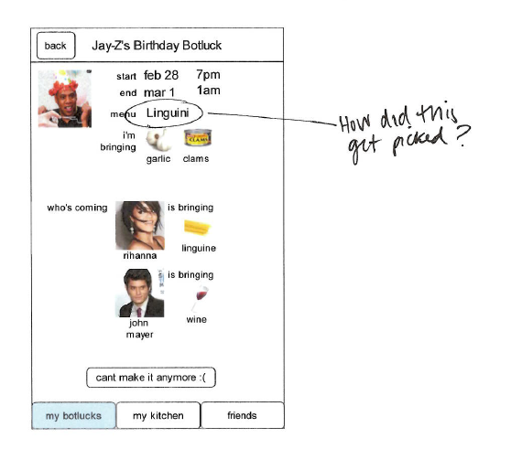

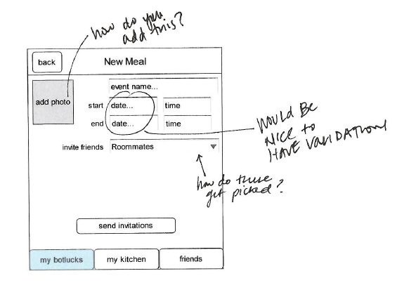

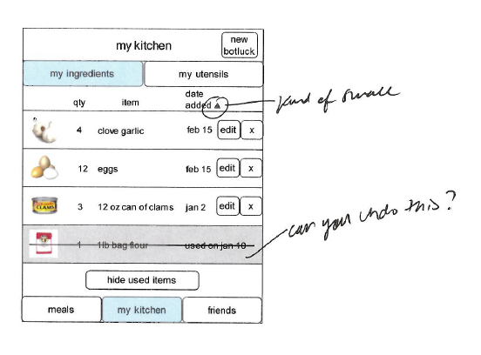

## Notes from In-Class User Testing

- first view of window requires you to scroll down immediately... possibly consider less vertical padding

- want login to work on enter press

- creating & sending invitations: the ellipsis at the end of the alert made user think he had to wait prior to hitting ok

- after sending invitation, should send user to the meal

- utensils/ingredients: want to see quantity of each thing we have

- want to be able to click on robot to go home

- want to be able to click on meal image to view it

- consider getting rid of "past botlucks" home page, and then change navigation to be "past botlucks" isntead of "my botlucks"

- how to log out?

- navigation should be visible at all times

- want to eb able to click on all photos

- want a way to add friends/ populate potential list of friends

- need a meal name input section

- once startime chosen, auto chance end time to be an hour later

- price per unit is confusing, just say price

- REMOVE TEMPLATE DATA (i.e rihanna, beyonce, and Jay-Z

make sure karma works

link to meal info page from somewhere

make people have friends

light yellow is weird

show amount next to ingredients in my kitchen

get rid of utensils?

clicking header should go home

get rid of default html